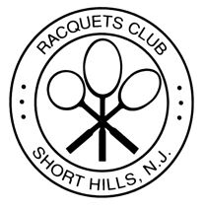

**Package A – The Princess Package $18 per child**

White table linens with pink cloth napkins- all princesses will receive a small tiara

Buffet lunch to include:

Mac and Cheese, Chicken Fingers and Fries, Vegetable Crudite,

Grilled Cheese, Fresh Sliced Fruit Platter

Soft drinks included plus choice of a mini-cupcake tower or

Make-Your-Own-Sundae Bar

**Package B- The Superhero Party $18 per child**

White table linens with red cloth napkins – All superheroes will receive a mask

Buffet lunch to include:

Mac and Cheese, Chicken Fingers and Fries, Vegetable Crudite,

Grilled Cheese, Fresh Sliced Fruit Platter

Soft drinks included plus choice of a mini-cupcake tower or

Make-Your-Own-Sundae Bar

**Package C – Make Your Own Pizza Party**  (limit to 25 guests) $18 per child

Red Plastic Table Linens with White Paper Napkins

Each child will get an apron to wear while they roll out their dough and

Pick their toppings for their pizza (pepperoni, meatballs, basil,

mozzarella, peppers, onions, diced ham and pineapple)

The pizza will then go into our ovens and will be served to them tableside

There will be a vegetable crudité on each table so they can snack

while they wait for their creation to cook

Soft drinks included plus choice of a mini-cupcake tower or

Make-Your-Own-Sundae Bar

**Package D – Standard Birthday package** $18 per child

White table linens with a color of cloth napkins to be decided

Buffet lunch to include:

Mac and Cheese, Chicken Fingers and Fries, Vegetable Crudite,

Hamburger and Cheeseburger Sliders, Fresh Sliced Fruit Platter

Soft drinks included plus choice of a mini-cupcake tower or

Make-Your-Own-Sundae Bar

We can supply balloons and entertainment at additional costs. These prices are food and

beverage only. A 20% service charge and 6.625% NJ state sales tax is not included,

Contact [Deana@theracquetsclub.com](mailto:Deana@theracquetsclub.com) for more information

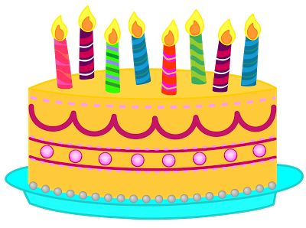

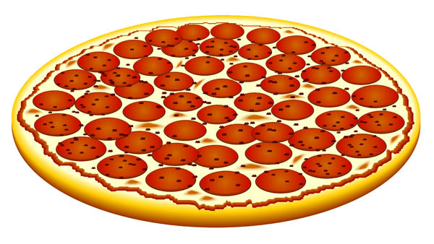



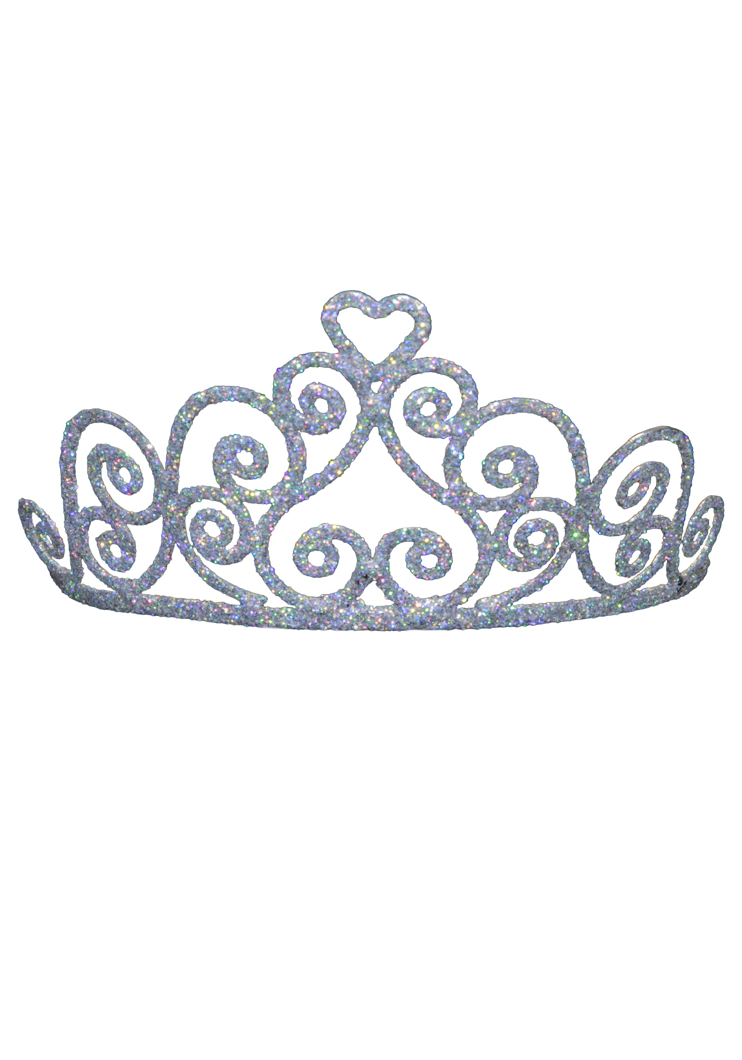

Children’s Birthday Party Packages