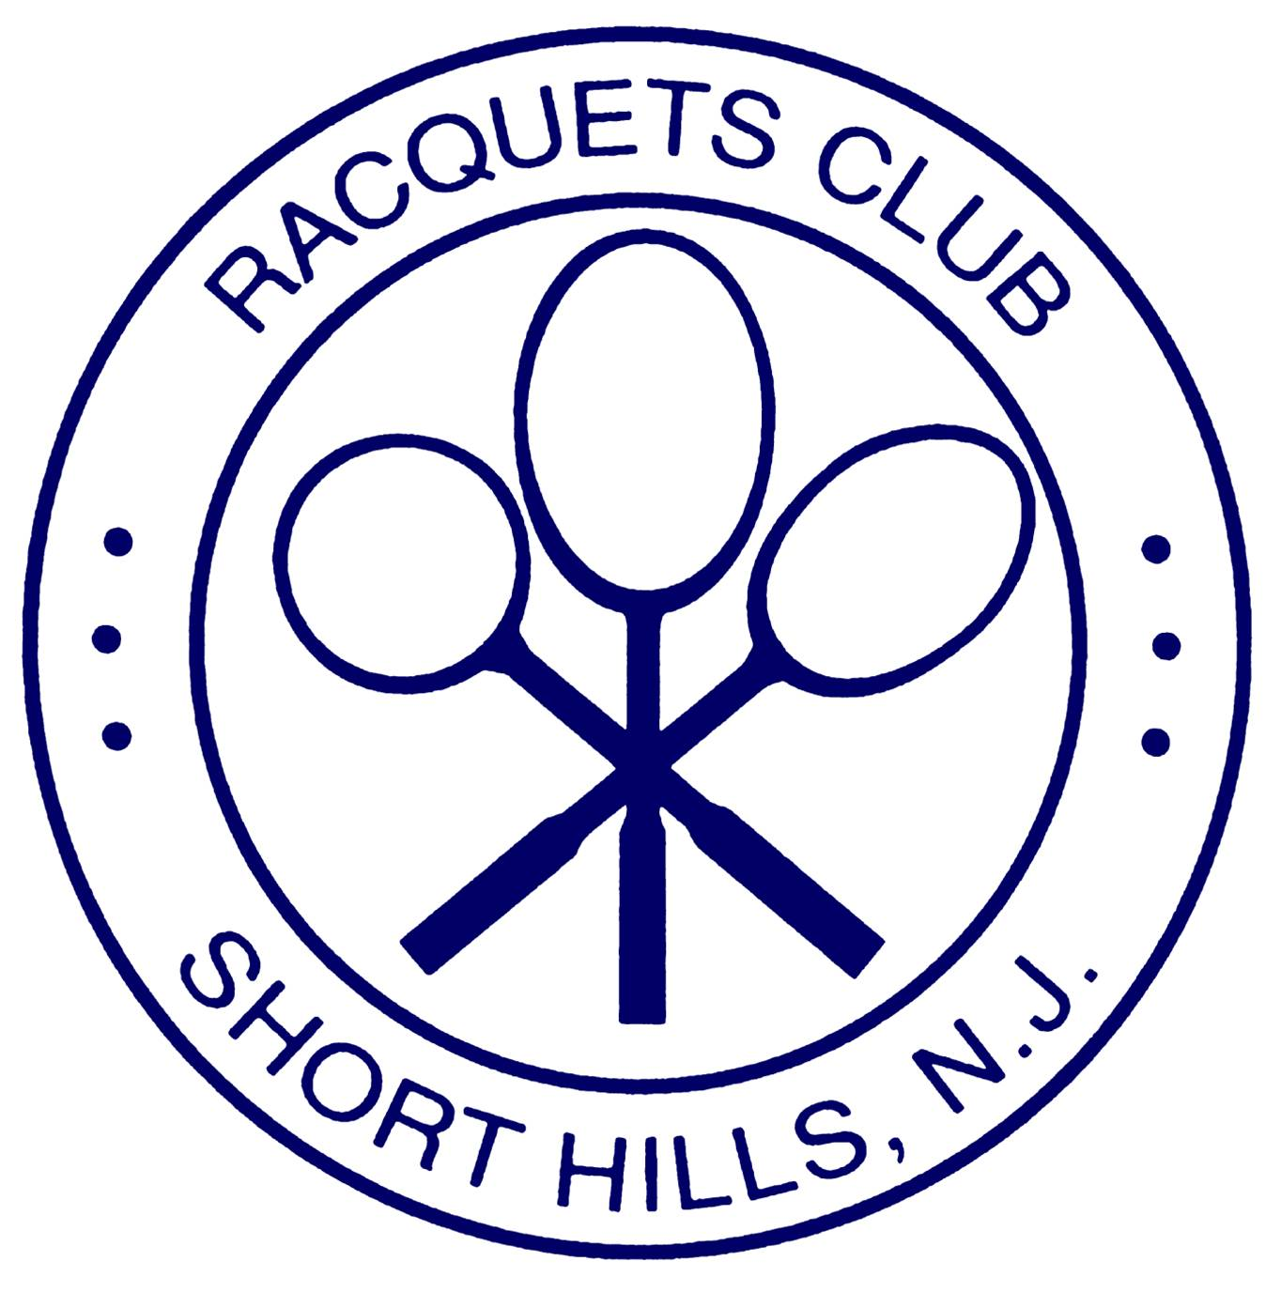

Luncheon Ideas

Package A

Soup as a first course : Choice of Butternut Squash, Country Tomato, Potato Leek, Cream of Mushroom, Chicken Rice, Matzo Ball, Shrimp Bisque or Cream of Asparagus

Each person is served a Salad as their next course : Choice of 1. Classic Caesar Salad, 2. Field Greens with Cucumber, Tomato, Onion and Balsamic Vinaigrette, 3. Baby Arugula with Goat Cheese, Dried Cranberries and Pine Nuts and Balsamic Vinaigrette, 4. Spinach Salad with Goat Cheese Croutons and Warm Bacon Dressing, 5. Spring Greens with Blueberries, Strawberries, Sunflower Seeds and a Raspberry Vinaigrette, 6. Chopped Fresh Romaine with Gorgonzola Cheese, Poached Pears, Parsnip Crisps and a Raspberry Vinaigrette, or 7. Mixed Gourmet Greens with Tangerine Wedges, Ricotta Salata and a Citrus Vinaigrette

Then a family style platter of Grilled Chicken, Grilled Salmon and Grilled Shrimp is placed on each table.

Soft drinks are included as well as coffee, tea and decaf
Dessert: Fresh fruit platter and sheet cake
$25 per person plus 20% service charge and NJ sales tax

The Racquets Club of Short Hills
162 Hobart Ave, Short Hills NJ 07078
973-379-6080 or rsvp@theracquetsclub.com

Package B

Appetizers – Choice of One: Butternut Squash Soup, Cream of Mushroom Soup, Fresh Sliced Fruit Plate, Penne alla Vodka or Eggplant Rollatini,
Caesar Salad, Kale and Quinoa Salad, Baby Arugula with Goat Cheese and Dried Cranberries, Romaine with Poached Pears, Gorgonzola Cheese and Parsnip Crisps or Mixed Seasonal Greens with Tomato, Onion and Cucumber

Entrees - Choice of Four:
Chicken Picatta, Lemon Chicken, Chicken Marsala, Oven Roasted French Chicken Breast, Chicken Florentine
Salmon with Dill Sauce, Triple Citrus Glazed Salmon, Salmon with Fresh Fruit Salsa, Sweet Chili Glazed Salmon, Grilled Salmon with Lobster Butter, African Spice Rubbed Salmon or Seasonal Fish Options
Chilean Sea Bass in Lemongrass Broth, Mediterranean Spice Crusted Sea Bass, Oven Roasted Sea Bass with Warm Tomato Vinaigrette
Rack of Lamb, Indian Lamb Stew
Sliced Hangar Steak Frites, Filet Mignon, NY Sirloin
Grilled Vegetable Plate, Pasta Primavera, Vegetable Wellington, Black Bean Cakes
Other entrees are available upon request and will be priced accordingly

Dessert
Fresh Fruit Platter and sheet cake

Coffee, Tea, Soft Drinks, Iced Tea and Lemonade
$34 per person plus 20% service charge and NJ sales tax

The Racquets Club of Short Hills
162 Hobart Ave, Short Hills NJ 07078
973-379-6080 or rsvp@theracquetsclub.com

Package C

Salad (One set salad)
Baby Mixed Greens with Seasonal Vegetables OR
Classic Caesar Salad with Brioche Croutons

Entrée Choice of 3

Grilled Chicken Breast with Sautéed Orzo and Fresh Lemon OR
Roasted Chicken Savoy with Balsamic, Parmesan and Fresh Herbs

Pan Seared Branzino with Citrus Coriander Sauce OR
Roasted Mahi Mahi with Fresh Fruit Salsa

Four Cheese Ravioli with Roasted Garlic Cream Sauce OR
Whole Wheat or Gluten Free Penne Pasta with Grilled Vegetables and Basil- Broth

Vegetable Wellington in Phyllo Dough OR Black Bean Cakes with Israeli Cous Cous and
Chipotle Sauce

Fresh Fruit Platter, Assorted Cookies and Brownies
Coffee, Tea, Soft Drinks

$28 per person plus 7% NJ sales tax and 20% service charge

The Racquets Club of Short Hills
162 Hobart Ave, Short Hills NJ 07078
973-379-6080 or rsvp@theracquetsclub.com

Package D

Appetizer (Choice of One)
Chef Jose’s Antipasto (eggplant rollatini, fried calamari, stuffed mushrooms, tomato
and mozzarella skewer, clams oreganata)
Potato Leek, Country Tomato, Asparagus Bisque or Cream of Mushroom Soup
Mixed Garden Greens with Cucumber, Tomato and Onion, Balsamic Vinaigrette

Entrée Choice of 4

Grilled Chicken Sandwich with Fresh Mozzarella, Sundried Tomato and Roasted Peppers on Foccaccia

Grilled Vegetable Panini

Seared Ahi Tuna over Soba Noodle Salad

Grilled Shrimp over Romaine, Poached Pears and Gorgonzola Cheese Salad, Raspberry Vinaigrette

Black Bean Cakes with Israeli Cous Cous and Chipotle Sauce

Sliced Steak Sandwich with Sautéed Onions, Peppers on Hoagie Roll

Fresh Fruit Platter, Assorted Cookies and Brownies
Coffee, Tea, Soft Drinks

$32 per person plus 7% NJ sales tax and 20% service charge

The Racquets Club of Short Hills
162 Hobart Ave, Short Hills NJ 07078
973-379-6080 or rsvp@theracquetsclub.com

